# Mark the Spot

This small application for MapInfo Pro can help you find a specific location using a lat/long.

## Using the application

First, you need to run the application in MapInfo Pro. If you use it often, it is advised to set the application to be auto-loaded from the *Tools* window.

You can activate the application in a number of ways:

* Double-click on the application in the *Tools* window
* Use the *Quick Search* field in the top right corner of MapInfo Pro and search for “*mark*” and then click on “*Mark the Spot*” under *Map*.
* Activate the control “*Mark the Spot*” directly from the *Find* dropdown on the *Map* tab in the *Selection* group
* Use the keyboard shortcut *Ctrl+M*.

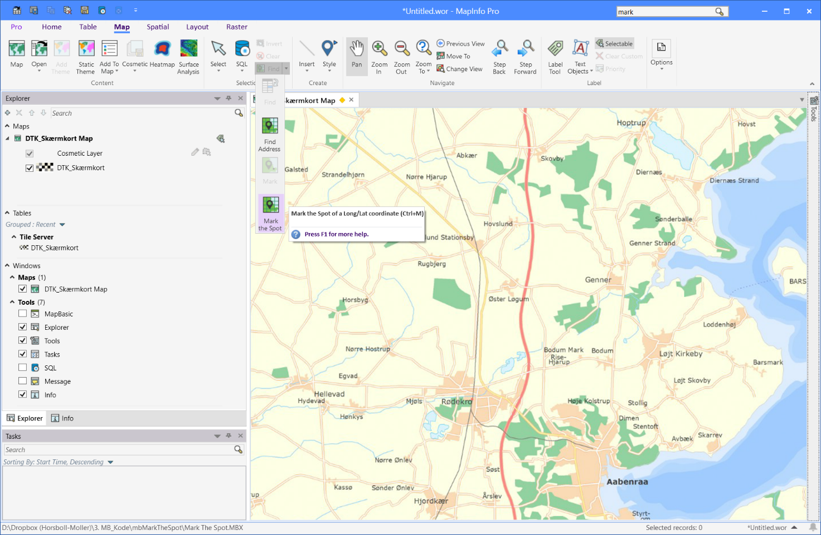

You will now see the “*Mark the Spot”* dialog on your screen.

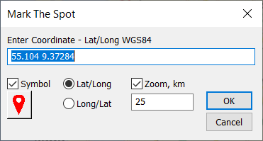In the “*Enter Coordinate*” field, you will see the current Lat/Long coordinate of the active map window. You can copy this for use in another application if needed.

Note that the order of the Latitude and Longitude value is controlled by the two radio-buttons (“*Lat/Long*” and “*Long/Lat*”) under the field. Changing the order will not change the order of the currently seen values in the field. It will however affect the order the next time the dialog is displayed, and it will affect how the values are used if you click on the “*OK*” button.

Paste or write the lat/long, that you want to center the map on. Note the order must match the order from the two radio-buttons as mentioned above. Note that the decimal point must be a point (.). This is chosen to make it easier when copying the lat/long to other application such as Google Maps and Bing Maps.

The “*Symbol*” checkbox controls if a point will be inserted into the Cosmetic layer when you click on the “*OK*” button. The style of the point can be set using the “*Symbol Style*” button just under the “*Symbol*” checkbox.

The “*Zoom*” checkbox controls if the map will be zoomed when you click on the “*OK*” button. If the “*Zoom*” checkbox is checked, the map will be zoomed to the value specified in the field below the “*Zoom*” checkbox. If it isn’t checked, the map will only be centered on the lat/long specified.

To center the map on the lat/long, and potentially zoom, click on the “*OK*” button.

To just close the dialog after having copied the lat/long, click on the “*Cancel*” button.